EYE WEB QUEST- Rose Neuro 2017 Due 1/19

You will learn about the eye by completing the following Webquest. READ and FOLLOW all instructions listed below in the order they appear. **Make sure that everything you type is IN YOUR OWN WORDS! Do NOT copy and paste!**

Purpose: To deepen the understanding of how the eye functions and how it utilizes light.

**Part 1: What is an Eye**

**Instructions:**

**1) Right click “open hyperlink” on the website address below. Type your answers to the question below from the information on this website. Type your answers directly in this word document.**

[**http://www.myeyeworld.com/files/eye_structure.htm**](http://www.myeyeworld.com/files/eye_structure.htm)

**List the FUNCTION of each of the parts of the eye:**

**a) lens:**

**b) cornea:**

**c) retina:**

**d) pupil:**

**e) iris:**

**f) sclera:**

**g) optic nerve:**

**h) ciliary body (muscle):**

2) Right click on each of the websites. Choose “Open hyperlink”. You will find a flash animation that will help you to understand the operation of the eye. When you complete them all, label the diagram below.

Flash animation 1-Eye Structure and Function

<http://www.kscience.co.uk/animations/eye_function_drag.htm>

Flash animation 2- Eye Structure

<http://www.kscience.co.uk/animations/eye_drag.htm>

Flash 3- structure

<http://www.kscience.co.uk/animations/eye.htm>



**Drag all the labels for parts AND functions below onto the diagram:**

a) PARTS:

Optic nerve

retina

lens

cornea

sclera

iris

ciliary bodies

pupil

b) FUNCTIONS:

Focuses light onto retina

transparent and focuses light

Tough outer coat

Changes size to control light

Gap that light passes through

Carries impulse to brain

Contracts to change lens shape

Contains light receptor cells

**BONUS: compare a human eye to a cow eye**

Look for the parts that you labeled on your human eye diagram! Complete the Venn Diagram comparing the similarities and differences between a human eyeball and a cow eyeball. **You will have to search the internet to find out about the cow eyeball.**

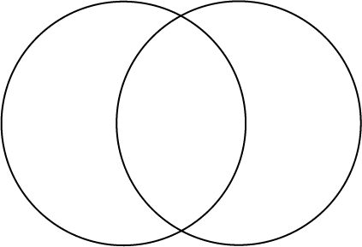

HUMAN EYE

COW EYE

BOTH